**Project Development Phase**

# Date 05 November 2022

Team ID Project Name

PNT2022TMID18706

# Visualizing and Predicting Heart Diseases with an Interactive Dashboard

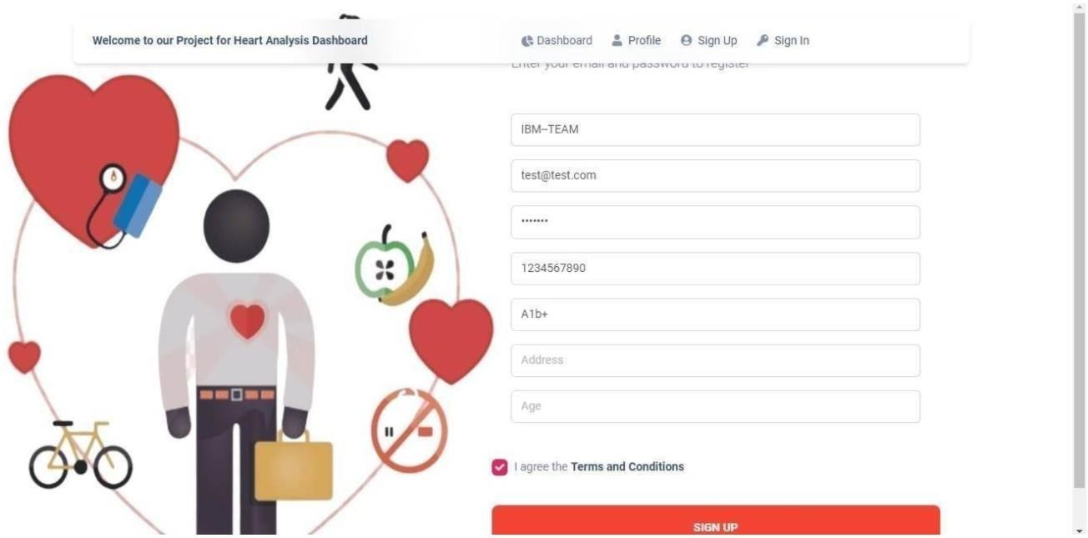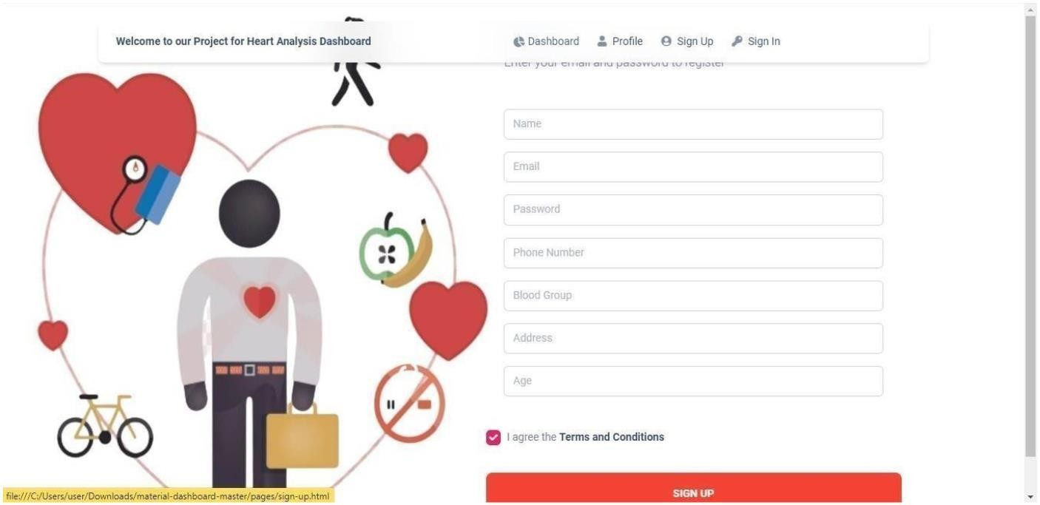

Sprint-1

**Registration**-Can register for the application by entering my email, password, and confirming my Password

**Login -** Can log into the application by entering email/Phone Number & password

